MINEWATCH
End-to-End Deployment & Operations Guide
AI-Enabled Real-Time Mine Subsidence Monitoring,
Prediction and Early Warning System
SMART INDIA HACKATHON 2026 | PROBLEM STATEMENT SIH26025

Team | MineWatch
PS Category | Hardware
Deployment Model | Surface sensor nodes over/around underground mine panels
System Objective | Continuous sensing → communication → AI analysis → prediction → warning

Deployment guide for mine officers, field deployment personnel, control-room operators and system administrators.

1. Solution Overview
MineWatch is a distributed surface-monitoring system intended to continuously observe ground conditions above underground coal mine panels. The proposed solution combines multi-parameter sensor nodes, 915 MHz LoRa communication, gateway-side data handling, AI/ML analysis and a GIS-enabled dashboard for live monitoring and early warning.
The deployment model used in this guide assumes that the sensor nodes are installed on the surface at defined monitoring locations. Each node is associated with a mine, panel and physical surface location so that every measurement can be mapped back to its source.

1.1 End-to-End System
1. SENSE | 2. IDENTIFY | 3. TRANSMIT | 4. PROCESS | 5. VISUALIZE | 6. WARN
Tilt  Vibration  Displacement  Crack/strain | Node ID  Location  Panel | 915 MHz  LoRa → Gateway | Storage  AI/ML  Sensor fusion | GIS map  Live values  Trends | Risk status  Alerts  SOS

The submitted solution specifies BNO085 for tilt/inclination, ADXL355 for vibration, and two FBG sensors for displacement/strain and crack-related monitoring. Nodes communicate with a central gateway using 915 MHz LoRa. Results are intended to be presented through a GIS-enabled web/mobile dashboard with live readings, deformation trends, predicted risk zones and alerts.

1.2 Deployment Principle
- Every physical node receives a unique Node ID.
- Every Node ID is associated with a defined surface monitoring point.
- The node is electrically and functionally checked before being marked Active.
- LoRa connectivity is verified through the gateway before commissioning.
- The gateway forwards/stores data for server-side processing and dashboard visualization.
- The officer verifies the node on the GIS dashboard before completing deployment.

2. Roles and Responsibilities
Role | Primary Responsibility | When Used
Deployment Officer | Install, identify, power, test and commission surface nodes. | Field deployment
System Administrator | Register nodes, locations, gateways and authorized users. | Before/after deployment
Control-Room Officer | Monitor live conditions, node health, trends and alerts. | Routine operation
Maintenance Technician | Resolve sensor, power, node or communication faults. | Fault condition
Mine Management | Review risk information and operational reports. | Decision/support

3. Pre-Deployment Preparation
Before entering the field, the deployment team prepares the hardware, identities and deployment records.

3.1 Hardware Checklist
- STM32-based sensor node
- BNO085 tilt/inclination sensor
- ADXL355 accelerometer
- FBG sensors and optical components where required
- 915 MHz LoRa module
- Primary power supply and battery backup
- 3.3 V / 5 V regulation
- SOS/emergency button
- Protective enclosure and mounting hardware
- LoRa gateway and gateway power/network connection

3.2 Deployment Record
Prepare one record for each node containing:
- Node ID
- Mine
- Panel
- Surface monitoring location
- GIS coordinates
- Sensor configuration
- Assigned gateway
- Deployment date/time
- Deployment officer

3.3 Node Placement Layout and Inter-Node Spacing
Node positions are not selected arbitrarily. Each node location is fixed by a planned survey grid over the panel boundary, and the grid spacing is set so that every point on the panel surface remains within monitoring resolution and every node remains within reliable LoRa range of its gateway. This section gives the placement rule used to generate the grid, a worked reference layout with inter-node distances, and the field procedure for verifying that installed positions match the plan.

3.3.1 Placement Principle
- Node positions are laid out on a rectangular grid over the surface projection of the panel, aligned to the panel's long axis (strike) and short axis (dip), using the panel boundary coordinates from the mine survey plan as the reference frame.
- The grid origin (0 m, 0 m) is fixed at a known survey monument or a corner of the panel boundary so that every node position can be reproduced from the deployment record without re-surveying the whole panel.
- Row spacing and column spacing are equal by default, producing a square grid; unequal spacing is used only where the panel's aspect ratio or access constraints require it, and any deviation is recorded against the affected node IDs.
- Spacing is tightened near a goaf edge, fault, old workings boundary or any zone flagged high-risk in the geotechnical assessment, and relaxed only in zones confirmed low-risk by the same assessment.
- The gateway is placed as close to the geometric centre of the node grid as terrain and access allow, so that the longest node-to-gateway path is minimised.

3.3.2 Standard Spacing Rule
Unless the site-specific geotechnical assessment specifies otherwise, apply the following default spacing:
- Normal-risk zone: 50 m spacing between adjacent nodes in both grid directions.
- Reinforced zone (within 50 m of a goaf edge, fault trace or known weak-roof boundary): 25 m spacing, i.e. one additional node inserted at the midpoint of each affected grid edge.
- Minimum of one node within 25 m of any active SOS-relevant structure (haul road, surface facility, access point) located above or adjacent to the panel.
- Maximum planned node-to-gateway straight-line distance: 500 m for open surface terrain with clear line of sight; reduce this figure where vegetation, stockpiles, buildings or terrain undulation will obstruct the LoRa path, and confirm the working figure with a link test before finalising node count.

3.3.3 Reference Grid Layout — Worked Example
The following layout illustrates the method for a reference panel measuring 200 m (strike) by 100 m (dip), using 50 m spacing. Apply the same method to the actual panel dimensions taken from the survey plan; node count and coordinates will differ accordingly.
Plan view — reference grid, 50 m spacing (not to scale)
R1: ● --- 50 m --- ● --- 50 m --- ● --- 50 m --- ● --- 50 m --- ●
| | | | |
50 m 50 m 50 m 50 m 50 m
| | | | |
R2: ● --- 50 m --- ● --- 50 m --- [GW] --- 50 m --- ● --- 50 m --- ●
| | | | |
50 m 50 m 50 m 50 m 50 m
| | | | |
R3: ● --- 50 m --- ● --- 50 m --- ● --- 50 m --- ● --- 50 m --- ●
C1 C2 C3 C4 C5
● = sensor node [GW] = gateway diagonal node-to-node spacing = 70.7 m
Node IDs follow the pattern MW-R⟨row⟩C⟨column⟩. Rows are numbered from the panel boundary edge nearest the return airway (R1) toward the intake side (R3); columns are numbered from the survey origin along the strike direction (C1 to C5). The gateway mast is co-located with grid position R2-C3, at the centre of the layout.
Node ID | Grid Position | X-offset (m) | Y-offset (m) | Dist. to next node, same row (m) | Dist. to next node, same column (m) | Dist. to gateway (m)
MW-R1C1 | R1-C1 | 0 | 0 | 50 | 50 | 111.8
MW-R1C2 | R1-C2 | 50 | 0 | 50 | 50 | 70.7
MW-R1C3 | R1-C3 | 100 | 0 | 50 | 50 | 50.0
MW-R1C4 | R1-C4 | 150 | 0 | 50 | 50 | 70.7
MW-R1C5 | R1-C5 | 200 | 0 | — | 50 | 111.8
MW-R2C1 | R2-C1 | 0 | 50 | 50 | 50 | 100.0
MW-R2C2 | R2-C2 | 50 | 50 | 50 | 50 | 50.0
MW-R2C3 (Gateway mast) | R2-C3 | 100 | 50 | 50 | 50 | 0.0
MW-R2C4 | R2-C4 | 150 | 50 | 50 | 50 | 50.0
MW-R2C5 | R2-C5 | 200 | 50 | — | 50 | 100.0
MW-R3C1 | R3-C1 | 0 | 100 | 50 | — | 111.8
MW-R3C2 | R3-C2 | 50 | 100 | 50 | — | 70.7
MW-R3C3 | R3-C3 | 100 | 100 | 50 | — | 50.0
MW-R3C4 | R3-C4 | 150 | 100 | 50 | — | 70.7
MW-R3C5 | R3-C5 | 200 | 100 | — | — | 111.8
Distances in the table are straight-line (Euclidean) distances calculated from the planned grid coordinates. Diagonal neighbour distance (e.g. R1-C1 to R2-C2) is 70.7 m throughout this layout and is not repeated in every row.

3.3.4 Gateway Placement and Link-Distance Check
- Place the gateway mast at, or as close as practicable to, the centre grid position so the longest node-to-gateway distance is minimised rather than left to the far edge of the panel.
- In the reference layout, the maximum planned node-to-gateway distance is 111.8 m (corner nodes R1-C1, R1-C5, R3-C1, R3-C5), well inside the 500 m planning limit given in 3.3.2.
- Planned distance is a starting point, not a substitute for a field link check. At each node, confirm RSSI and SNR at the gateway meet the system's minimum acceptable margin before commissioning; a short planned distance with an obstructed path can perform worse than a longer, clear one.
- Where a node fails the link check from its planned grid position, relocate it along the panel boundary to the nearest point with a clear path to the gateway, record the as-built offset from the planned position, and re-run the commissioning checklist in Section 5.

3.3.5 Field Verification of Node Positions
1. Mark planned positions — Before mobilising sensors, mark each planned grid position (survey stake or paint mark) using the offsets in the deployment record, working outward from the fixed grid origin.
2. Survey the as-built position — At each marked position, record the actual coordinates using handheld GNSS (±3 m accuracy) or, where available, RTK GNSS or a total station tied to the mine survey control network (±0.3 m accuracy).
3. Check deviation against tolerance — Compare the as-built coordinates to the planned grid coordinates. Accept the position if the deviation is within ±3 m (handheld GNSS) or ±0.3 m (RTK/total station); otherwise adjust the node position and re-survey.
4. Record as-built values — Enter the as-built coordinates, not the planned grid coordinates, into the deployment record and the GIS registration step (Field Deployment Procedure, step 9). The GIS map must reflect where the node actually is.
5. Re-check inter-node spacing — Confirm that no gap between adjacent as-built node positions exceeds the applicable spacing limit (50 m normal-risk, 25 m reinforced zone) given in 3.3.2; if it does, insert an additional node at the midpoint of the oversized gap before completing deployment.

4. Field Deployment Procedure
The following sequence is the standard field procedure from arrival at the monitoring point to dashboard verification.
- Receive the deployment assignment — Confirm the mine, panel, monitoring area, number of nodes and assigned gateway.
- Locate the monitoring point — Reach the surface location assigned to the node and verify that it matches the deployment record.
- Verify the node identity — Check the physical Node ID label against the deployment record before installation.
- Install the node — Securely mount the enclosure and install/connect the required sensors.
- Connect FBG sensing where applicable — Install the optical/FBG sensing arrangement required for displacement, strain or crack-related monitoring.
- Power the node — Connect the primary supply and verify that the battery-backup system is available.
- Run node diagnostics — Check controller, BNO085, ADXL355, FBG subsystem where present, power and communication hardware.
- Establish LoRa communication — Confirm that the node successfully transmits to the assigned 915 MHz LoRa gateway.
- Register the location — Associate the Node ID with its mine, panel and GIS surface coordinates.
- Verify gateway reception — Confirm that valid sensor packets are being received by the gateway.
- Verify server/data path — Confirm that gateway data reaches the monitoring/data system and is available for processing.
- Commission the node — Only after all checks pass, change the node status to Active.
- Verify on the dashboard — Confirm the node appears at the correct map location and live data is visible.

5. Node Commissioning
A node must pass the commissioning checklist before it becomes part of the active monitoring network.
Check | Expected Result | Status
Node identity | Correct Node ID | PASS / FAIL
Power | Primary supply and backup available | PASS / FAIL
BNO085 | Sensor responding | PASS / FAIL
ADXL355 | Sensor responding | PASS / FAIL
FBG subsystem | Valid response where installed | PASS / FAIL / N/A
LoRa | Gateway receiving packets | PASS / FAIL
SOS | Button/event path available | PASS / FAIL
Location | Mine/panel/coordinates correct | PASS / FAIL
Server path | Data visible to processing system | PASS / FAIL
Dashboard | Node visible and mapped correctly | PASS / FAIL

Commissioning rule: A node is marked ACTIVE only after the physical, sensor, communication and dashboard checks have passed.

6. Gateway and Data Flow Verification
The gateway is the communication bridge between distributed surface nodes and the monitoring platform.
Surface sensor node ↓
915 MHz LoRa ↓
Central/local gateway ↓
Local storage and/or processing ↓
Server/database ↓
AI/ML analysis ↓
GIS dashboard ↓
Operator alert/notification
The proposed architecture also includes offline capability at the gateway: local storage/processing can maintain monitoring during internet loss and synchronize when connectivity returns.

7. Officer Dashboard Login and Verification
After field commissioning, the authorized officer moves to the MineWatch monitoring interface.
- Open the MineWatch web/mobile dashboard from an authorized device.
- Enter the assigned officer credentials.
- Complete authentication and open the monitoring dashboard.
- Confirm that the assigned mine and panel are visible.
- Open the GIS map and locate the newly commissioned node.
- Open the node detail view and verify live readings.
- Check node health, battery and LoRa communication status.
- Confirm that the node status is Active/Online.

7.1 Dashboard Sections
Section | Purpose
Overview | Overall node health, gateway status, current warnings and system condition.
GIS Map | Spatial location of nodes, deformation information and risk zones.
Nodes | Individual sensor readings, battery, communication and health status.
Alerts | Abnormal-condition warnings, SOS events and alert history.
Reports | Historical readings, deformation trends and system records.

8. Normal Monitoring Operation
Once commissioned, nodes operate continuously and the officer's role shifts from installation to monitoring.
- Check gateway and network health at the beginning of the shift.
- Check the number of Active/Online nodes.
- Review battery and sensor-health warnings.
- Review the GIS map for abnormal or changing areas.
- Review deformation and sensor trends rather than relying only on a single reading.
- Review generated warnings and notifications.
- Record and escalate events according to the mine's safety procedure.

9. Abnormal Condition and Alert Workflow
MineWatch is designed to combine tilt, vibration, displacement/strain and crack-related information with temporal and spatial analysis. An abnormal condition should therefore be treated as an event for verification and response rather than as an isolated sensor value.
- Dashboard generates an abnormal-condition warning.
- Officer opens the alert and identifies the affected node(s) and surface location.
- Officer reviews current readings and historical trend.
- Officer checks neighbouring nodes for spatial correlation.
- Officer acknowledges and records the event according to site procedure.
- Mine personnel perform the required field verification or safety action.
- Event is retained in the monitoring history for subsequent analysis.

9.1 SOS Event
When the SOS button is activated, the node sends an emergency event containing the node identity/status and location through the monitoring system. The control-room officer uses the dashboard event to identify the affected surface location and follows the mine's emergency response procedure.

10. Communication or Internet Failure
A communication failure must be distinguished between a node-to-gateway failure and an internet/server connectivity failure.
Condition | Expected System Behaviour | Officer Action
Node ↔ Gateway lost | Node/gateway communication fault is indicated. | Check node power, LoRa link and physical installation.
Gateway ↔ Internet lost | Gateway continues local storage/processing where configured. | Monitor local gateway status; synchronize after connectivity returns.
Sensor fault | Node reports sensor/self-diagnostic fault. | Dispatch maintenance technician.
Low battery | Node health reports battery warning. | Schedule power/battery maintenance.

11. Deployment Completion Record
At the end of each deployment, the officer completes the commissioning record.
Mine: ______________________________________________
Panel: _____________________________________________
Deployment Area: ____________________________________
Node ID(s): _________________________________________
Gateway ID: _________________________________________
Deployment Date/Time: _______________________________
Officer: ____________________________________________
Number of Nodes Installed: ___________________________
Number of Nodes Commissioned: ________________________
Number of Nodes Requiring Maintenance: _______________
Dashboard Verification: PASS / FAIL
Deployment Notes: ____________________________________

12. End-to-End Operational Flow
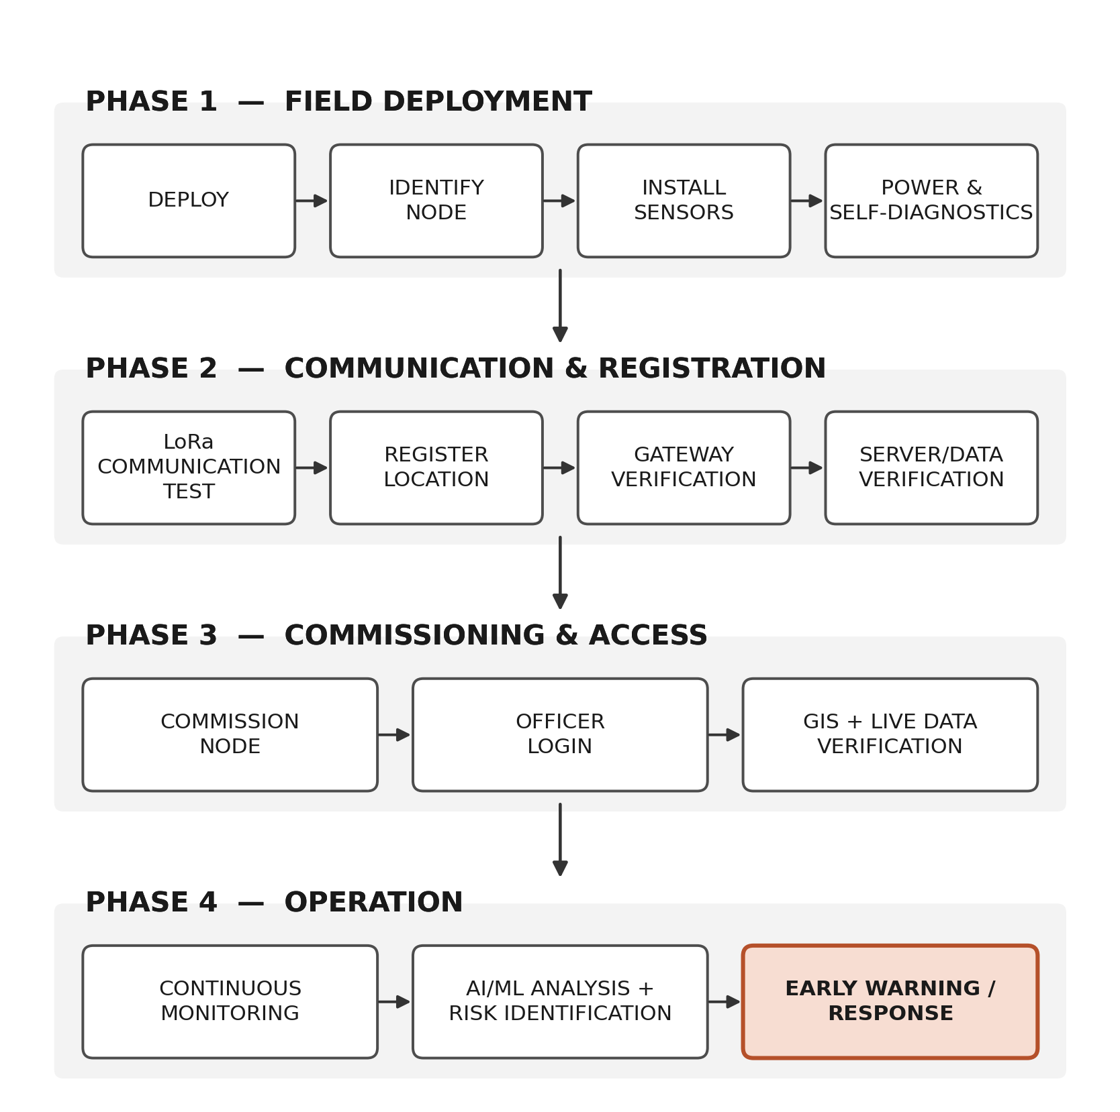
Figure 1. End-to-end operational flow, from field deployment to early warning and response.

13. Solution Coverage for SIH26025
This deployment workflow connects the physical field deployment directly to the intended MineWatch problem solution: distributed surface sensing of ground conditions, long-range wireless communication, data storage and analysis, AI/ML-based identification of abnormal deformation patterns, GIS-based visualization and early warning.
PS Requirement / Need | MineWatch Deployment Response
Continuous ground monitoring | Surface sensor nodes continuously collect tilt, vibration, displacement/strain and crack-related data.
Large-area deployment | Distributed nodes communicate over 915 MHz LoRa to a gateway.
Early detection | AI/ML analysis uses real-time and historical sensor information to identify abnormal patterns.
Spatial understanding | GIS associates each measurement with its surface monitoring location and displays risk zones.
Operational reliability | Battery backup, self-diagnostics and gateway-side offline capability support continued operation.
Emergency support | SOS events can be transmitted with node status and location.
Scalability | The architecture is intended to scale from sensor → panel → mine → coalfield.

SOURCE AND SCOPE
Prepared from the MineWatch SIH 2026 submission for Problem Statement SIH26025. The submitted material defines the sensing architecture, LoRa communication, gateway/data flow, AI/ML analysis, GIS dashboard, self-diagnostics, battery backup and SOS functions. Specific authentication screens, database schemas, exact dashboard controls and deployment-site safety procedures are implementation details and should be finalized by the project/system team and mine operator.

